P.C.S. Home Health Inc.

Employment Application

Applicant Information
Full Name: |  |  |  | Date:
 | Last | First | M.I.

Address:
 | Street Address | Apartment/Unit #

 | City | State | ZIP Code

Phone: |  | Email

Date of Birth: |  | Social Security No.: |  | Desired Salary: | $

Position Applied for:

Date Available:_________________ Days Available: M T W TH F SAT SUN

What is your Shift Preference: Days Evenings Nights Weekends
Are you a citizen of the United States? | YES | NO | If no, are you authorized to work in the U.S.? |  | YES | NO

Have you ever worked for this company? | YES | NO | If yes, when?

Have you ever been convicted of a felony? |  | YES | NO | Are you applying for: Full Time Part Time PRN
If yes, explain:

Education
High School: |  | Address:

From: |  | To: |  | Did you graduate? | YES | NO | Diploma:

College: |  | Address:

From: |  | To: |  | Did you graduate? | YES | NO | Degree:

Other: |  | Address:

From: |  | To: |  | Did you graduate? | YES | NO | Degree:

References
Please list three professional references.
Full Name: |  | Relationship:
Company: |  | Phone:
Address:
Full Name: |  | Relationship:
Company: |  | Phone:
Address:
Full Name: |  | Relationship:
Company: |  | Phone:
Address:

Previous Employment
Company: |  | Phone:
Address: |  | Supervisor:

Job Title: |  | Starting Salary: | $ | Ending Salary: | $

Responsibilities:

From: |  | To: |  | Reason for Leaving:

May we contact your previous supervisor for a reference? | YES | NO

Company: |  | Phone:
Address: |  | Supervisor:

Job Title: |  | Starting Salary: | $ | Ending Salary: | $

Responsibilities:

From: |  | To: |  | Reason for Leaving:

May we contact your previous supervisor for a reference? | YES | NO

Company: |  | Phone:
Address: |  | Supervisor:

Job Title: |  | Starting Salary: | $ | Ending Salary: | $

Responsibilities:

From: |  | To: |  | Reason for Leaving:

May we contact your previous supervisor for a reference? | YES | NO

Disclaimer and Signature
A background screening via the Family Care Safety Registry must be performed prior to first day. Please disclose all criminal convictions, findings of guilt, pleas of guilt, and pleas of nolo contendere to any misdemeanor or felony charge, to include any suspended imposition of sentence, suspended execution of sentence or period of probation or parole or provide a statement that there is no record of such background. Failure to disclose any criminal information is a violation of the law. All convictions will be identified by the FCSR, including convictions more than 10 years go.

Have you been convicted or plead “no contest” to any criminal offense(s) within the last ten (10) years? Yes No
If “Yes” indicate: nature of offense, date, court and disposition. (A conviction will not necessarily disqualify you from consideration for employment. ____________________________________________________________________________________________________________________________________________________________________________________

I certify that my answers are true and complete to the best of my knowledge.
If this application leads to employment, I understand that false or misleading information in my application or interview may result in my release.
I authorize P.C.S Home Health INC to solicit information regarding my character, general reputation, criminal history, previous employment, education, military service, and similar background information, and to contact any and all references I have given on my application and resume:
I hereby release all parties and persons connected with any such request for information from all claims, liabilities and damages for any reason arising out of the furnishing of such information. If employed, I release P.C.S Home Health INC from any liability for future references it may provide regarding my work history with P.C.S Home Health INC.
I understand that P.C.S Home Health INC is an “at-will” employer. I understand that my employment can be terminated with or without cause, and with or without notice at any time, at the option of either P.C.S Home Health INC or myself. I hereby acknowledge that I have read and understand the preceding statements.
Signature: |  | Date:

Authorization for Release of Information and Criminal Records Check

Legal Last Name | Legal First Name | Legal Middle Name

HIPPA PRIVACY STATEMENT
Acknowledgement
P.C.S. Home Health Care Inc is a covered entity and is required by law to maintain the privacy of our clients’ personal identifiable health information and to provide clients with notice of our legal duties and privacy practices with respect to personal health information.
Understanding Health information Privacy
The HIPPA Privacy Rule provides federal protections for personal information held by covered entities and assures clients certain rights with respect to their information. The privacy rule is balanced so that it permits the disclosure of personal information needed for client care and other important purposes.
The Security Rule is a set of federal security standards which specifies series of administrative, physical, and technical safeguards for covered entities to use to assure confidentiality, integrity, and availability of electronic protected health information.
Permitted Use and Disclosures
We may use and disclose personal health information necessary for your treatment. That means that we can share information with your physician, staff and other professionals involved in your care. We may also release your personal health information to another health care facility or professional who is not affiliated with our organization who will be providing treatment to you. For instance, if you are admitted to the hospital, we may release your personal information to the hospital so that an appropriate plan of care can be developed for you.
Disclosure without Authorization
- We may release your personal health information for any purpose required by law.
- We may release your personal health information for public health activities such as: (reporting a disease, injury, birth, and death, and required public health investigations).
- We may release your personal health information to the Food and Drug Administration, if necessary, to report adverse event, product defects, or to participate in product recalls.
- We may release your personal health information if required by law to a government oversight agency conducting audits, investigations, or civil or criminal proceedings.
- We may release your personal health information if required to do so by a court or administrative ordered subpoena or discovery request, in most cases you will have notice of such release.
- We may release your personal health information to coroners and/ or funeral directors consistent with law.
- We may release your personal health information to worker’s compensation agencies if necessary for your worker’s compensation benefit determination.

The client has the right to
- Request restrictions on the use and disclosure of their personal health information for the purpose of treatment, payment, or health care operations. We are not required to agree with your restriction request but will attempt to accommodate reasonable request when appropriate.
- Have the right to copy and/ or inspect as much of the personal health information that the agency retains on their behalf. All request for access must be made in writing and signed by you or your representative.
- May ask us to amend the health information if they believe that it is incorrect or incomplete. Your request must be submitted in writing and must include a reason to support the amendment.
- May request a list of none-routine disclosures that we have made of your medical information over the previous six (6) years. This does not include disclosures we make for your treatment, to seek payment for our services, or for our normal business operations as noted in the section on permitted uses of disclosures, or for those you authorize in writing.
File a complaint if they believe their privacy rights have been violated.

Employee Signature _________________________________

Date ____________________________________________

Code of Ethics

- Do NOT drive the client’s car for any reason.

- Do NOT transport the client in your car for any reason.

- Do NOT consume the client’s food or drink (except water, also able to use client’s bathroom)

- Do NOT discuss personal problems or religious or political beliefs with the client.

- Do NOT accept gifts or tips (items, things or monetary).

- Do NOT bring other persons (including children) to the client’s home.

- Do NOT consume alcoholic beverages or use medicine or drugs for purposes other than medical, in the client’s home or prior to service delivery.

- Do NOT smoke in the client’s home.

- Do NOT solicit or accept money or good for personal gain from the client.

- Do NOT violate the client’s privacy and confidentiality of information and records.

- Do NOT purchase any item from the client even at fair market value.

- Do NOT assume control of the financial and/or personal affairs of the client or of his/her estate including power of attorney, conservatorship, or guardianship.

- Do NOT move in with the client, nor spend additional time with the client outside of scheduled work time.

- Do NOT take anything from the client or remove any items from the client’s home.

- Do NOT commit any act of abuse, neglect and/or exploitation toward the client or any persons in their home.

_________________________ _________________________ _____/_____/____
Employee (Print Name/Title) Employee (Signature) Date

PCS Home Health Inc.

Client Bill of Rights

- The client will be fully informed on his/her rights and responsibilities by PCS Home Health Inc.

- The client has the right to be treated with respect and dignity at all times.

- The client has the right to have all personal and medical information kept confidential at all times.

- The client has the right to manage the services provided, to the best of their ability, within the written guidelines of the authorized care plan.

- The client has the right ot know PCS Home Health Inc. implemented grievance procedure and how to make a complaint about the service and receive cooperation to reach a resolution, without fear of retribution.

- The client has the right to receive a copy of the Code of Ethics under which his/her services are provided.

- The client has a right to refuse treatment and to be informed of the consequences of his/her actions.

- The client has the right to receive service services without regard to race, religion, creed, color, age, gender, national origin or sexual orientation.

If you suspect a senior disabled adult is being abused, neglected or financially exploited, call the Missouri Adult Abuse and Neglect Hotline at 1-800-392-0210, their hours of operation are 7:00 a.m. to 12:00 a.m. Phone lines are answered 365 days a year, seven (7) days a week. Hearing-impaired persons may call the Telecommunications Device for the Deaf (TDD), at 1-800-735-2466 or 1-800-735-2966 to utilize Relay Missouri. In cases of abuse, neglect of exploitation….Silence is NOT golden.

_________________________ _________________________ _____/_____/_____
Employee (Print Name) Employee (Signature) Date

_________________________ _________________________ _____/_____/____
Witness (Print Name) Witness (Signature) Date

Emergency and Back Up Plan

Consumer Name: ____________________ Date: _______________
Primary Doctor’s Name/Phone: _____________________________________________
Preferred Hospital Name/Phone: ____________________________________________

Steps taken if attendant does not show up or work:
______________________________________________________________________________________________________________________________________________________________________________________________________________________________________________________________________________________________________________________________________________________________________________________________________
Steps taken in the event of a natural or manmade disaster:
______________________________________________________________________________________________________________________________________________________________________________________________________________________________________________________________________________________________________________________________________________________________________________________________________

(Please Circle answer)
Do you have candles or flashlights? Y N
Do you have non-perishable foods on hand? Y N
Do you have a First Aid Kit? Y N
Do you have a back-up supply of medications? Y N
List Back up attendants non-paid and paid:
Name: | Phone: | Relationship: | Approved Attendant
 |  |  | Y N
 |  |  | Y N
 |  |  | Y N
 |  |  | Y N

PERSONAL
CARE
SERVICES

COMPANY POLICY
COMMUNICABLE DISEASES

TO ALL PCS EMPLOYEES:
As part of the directive set by the Missouri Department of Health (19 CSR 20-20.020), the following regulation will be enforced by the staff of Personal Care Services.

- PCS will enforce the policy governing communicable diseases that prohibits the staff to come in contact with clients when you have a communicable condition, including colds or flu, and COVID.

- The PCS staff should be notified of all communicable diseases, including hepatitis and tuberculosis, so that this condition can be reported to the Missouri Department of Health.

This policy must be understood and your signature at the bottom of this page acknowledges your agreement to this policy.

Employee: ____________________________

Date: ____/____/____

GENERAL ORIENATION STATEMENT
For In-Home Service Providers

This is to acknowledge that, in addition to orientation training, I have received and read copies of the following items:

- Code of Ethics (based on DA CSR)
- Bill of Rights (based on DA CSR)
- Confidentiality Statement
- In-Home Service Standards for:
SSBG---------(13-CSR 15-7.021) and
Title XIX-----(13-CSR 70-91.0)
(Required for Supervisors only)

I understand that the services I perform will be guided by these items, and that any violations of them may be grounds for my dismissal.

__________________________ ______________
Signature Date

P.C.S. Home Health INC.
2020 Electronic Visit Verification Update

Dear Personal Care Attendant:
On December 13, 2016, the 21st Century CURES Acts (114 U.S.C 255) was signed into legislation.
This requires P.C.S. Home Health INC to utilize an Electronic Visit Verification ( EVV) system to document home health service delivery. Effective January 1, 2020, EVV is the only acceptable format for a Personal Care Attendant to clock in or out. Paper timesheets are no longer and option and per the federal government, if a Consumer or Client refuses to allow P.C.S. Home Health INC to use EVV, they are at risk for losing their home health services.
EVV or time edit slips must collect the information below about the services you receive in your home:
- Consumer & Clients Name
- Caregiver’s Name
- Type of service received, and any tasks or progress notes related to that service.
- Date of Service
- Time the service begins and ends.
- Location where service delivery begins and ends.
P.C.S. Home Health INC wants to ensure that we are compliant with laws. We also want to help our Consumer, Clients and Personal Care Attendants understand the importance of avoiding fraudulent activity. Falsification of EVV entries or time edit slips in the In-Home Services (IHS) or the Consumer Directed Services (CDS) program is considered a misuse of Medicaid funds, sometimes referred to as Medicaid fraud. P.C.S. Home Health INC does not tolerate falsification of EVV entries, time edit slips or Medicaid fraud. Putting false or fraudulent information into the EVV system or on a time edit slip is extremely serious and can be punishable by law.
According to the Missouri Attorney General, “falsifying EVV information or time edit slips in connection with the provision of personal care services” is considered Medicaid fraud. In addition, individuals who violate Medicaid fraud regulations may lose their Medicaid eligibility for life and be banned from receiving CDS or IHS services. The Attorney General may file criminal charges against Personal Care Attendants and/or Consumer or Clients for Medicaid fraud and there may be serious financial penalties and even prison time for violators.
If P.C.S. Home Health INC discovers an EVV entry or time edit slips that is believed to contain false or fraudulent information, or is told that falsification or fraud exists, P.C.S. Home Health INC will make the following reports as appropriate:
- Notify the Missouri Department of Health and Senior Services (DHSS) and Missouri Medicaid Audit and Compliance (MMAC).
- Cease or prevent billing of Medicaid based on EVV information believed to be false or fraudulent.
- Cease or prevent payment to the Personal Care Attendant based on EVV entry believed to be false or fraudulent.
- Notify the Missouri Attorney General’s office of EVV entry falsification that resulted in suspected Medicaid fraud.

P.C.S. Home Health INC.
2020 Electronic Visit Verification Update

Below are examples of Medicaid Fraud that P.C.S. Home Health INC will not hesitate to report if discovered:
- Clocking in and/or out of the EVV system for days/hours you did not actually work.
- Clocking in and/or out of the EVV system for more hours than you actually worked.
- Entering tasks (examples: bathing, dressing/grooming, meal preparation, errands) into the EVV system that you did not complete for the Consumer & Client.
- Clocking in and/or out of EVV system while completing task that are NOT approved on the Consumer & Clients & Clients Plan of Care (examples: yard work, pet care, home repair, etc.)
- Clocking in and/or out of the EVV system for days/hours the Consumer & Client is in the hospital, emergency room, physician’s office, nursing home, rehabilitation services, jail/prison or other facility.
- Clocking in and/or out of the EVV system for days/hours you are working for other people at the same time.
- Clocking in and/or out of the EVV system for days/hours you are on-the-clock or working for another Consumer & Client, agency, organization, or business at the same time.
- Clocking in and/or out of the EVV system for days/hours when someone other than you did the work.
- Clocking in and/or out of the EVV system for days/hours and you no longer authorized to work for the Consumer & Client for any reason.
- Clocking in and/or out of the EVV system for days/hours for Consumer & Client who is closed with P.C.S. Home Health INC.
- Clocking in and/or out of the EVV system for days/hours for a Consumer & Client who is deceased.
If you have any questions or need clarification about the information in this document, please do not hesitate to call P.C.S. Home Health INC @ (314) 388-1530.

Your signature below indicates that you have read and understood the information presented in this document. You further understand that P.C.S. Home Health INC will report all suspected fraudulent activity to the governing entities listed at the bottom of page 1 of this document.

Printed Name of Personal Care Attendant Date

Signature of Personal Care Attendant Date

Confidentiality Statement

I understand that all clients have a right to have all personal and medical information kept confidential.

Due to this right:
- I will not discuss any client with another client.

- I will not discuss any client with another homemaker, or anyone not directly connected with the case.

- I will not discuss any client with the public.

- I will keep all information I learn about clients private, discussing it only with supervisory staff as appropriate.

- I will be discrete when discussing clients with my supervisors, so others will not overhear.

I understand the clients’ right and need for privacy to be respected and I understand that if I violate this right, it may be grounds for my dismissal.

__________________________________ ___/___/___
Employee Signature Date

P.C.S. Home Health INC.

ALCOHOL AND DRUG FREE WORKPLACE POLICY

It is the intention of P.C.S. Home Health, INC. to maintain an alcohol and drug-free workplace. Unlawful manufacture, use, possession, or distribution of alcoholic beverages and controlled substances, as defined in the Controlled Substance Act (21.VS.c.802) in the workplace in prohibited.
Employees who violate this policy are subject to disciplinary action including suspension or termination. Violation can also result in, up to and including, a total denial of workers’ compensation benefits. I understand that that agency will require a blood test to establish the level of involved in a possible drug/alcohol related accident. Employees may also be required to successfully complete a drug/alcohol abuse or rehabilitation program in addition to, or in lieu of, disciplinary action. This policy includes employees who are found to be intoxicated or under the influence or non-prescription controlled substance when initially reporting for duty, while on duty, or while in the administrative offices of the agency. If an employee is convicted of criminal drug statute violation occurring in the workplace, the conviction will be reported to the appropriate contracting Federal agency within ten (10) days.
I herby certify that I have received a copy of the above stated policy. I understand its contents and I will abide by the terms of this policy. Furthermore, I will notify the Director of P.C.S. Home Health, INC. of any criminal drugs statute conviction for a violating occurring in the workplace no later than five (5) days after such a conviction.

Employee Name __________________________________ Date __________________

P.C.S. Home Health INC.

Protection Policy

In case any type of virus or communicable disease infects an employee, P.C.S. Home Health INC. is not responsible. P.C.S Home Health INC. will not be responsible for any payment or hospital visit or stay. Employees are responsible for P.C.S. Home Health INC. clients.

This policy shall be enforced to protect the agency from any lawsuits or any other legal actions.

The employees are not to have contact with any clients if you have any type of communicable disease such as colds, flu, hepatitis, or tuberculosis.

If you should obtain any communicable disease while employed at P.C.S. Home Health INC., please call in, so that a replacement can fill in for you. Please do not go to work.

Anyone in violation of this protection policy will be subject to disciplinary action or termination.

________________________ _____________
Employee Signature Date

________________________ _____________
Owner/Director Signature Date

P.C.S. Home Health INC.

Pay Rate & Banking Information

Employee Name: _____________________ Hire Date: ____________
Today’s Date: ______________ Pay Rate: ___________

Banking Information

Name of Bank: __________________________
Checking or Savings: _____________________
Routing Number: ________________________
Account Number: ________________________

_________________________ _______________
Employee Name (Print) Date

_________________________ ________________
Employee Name (Signature) Date

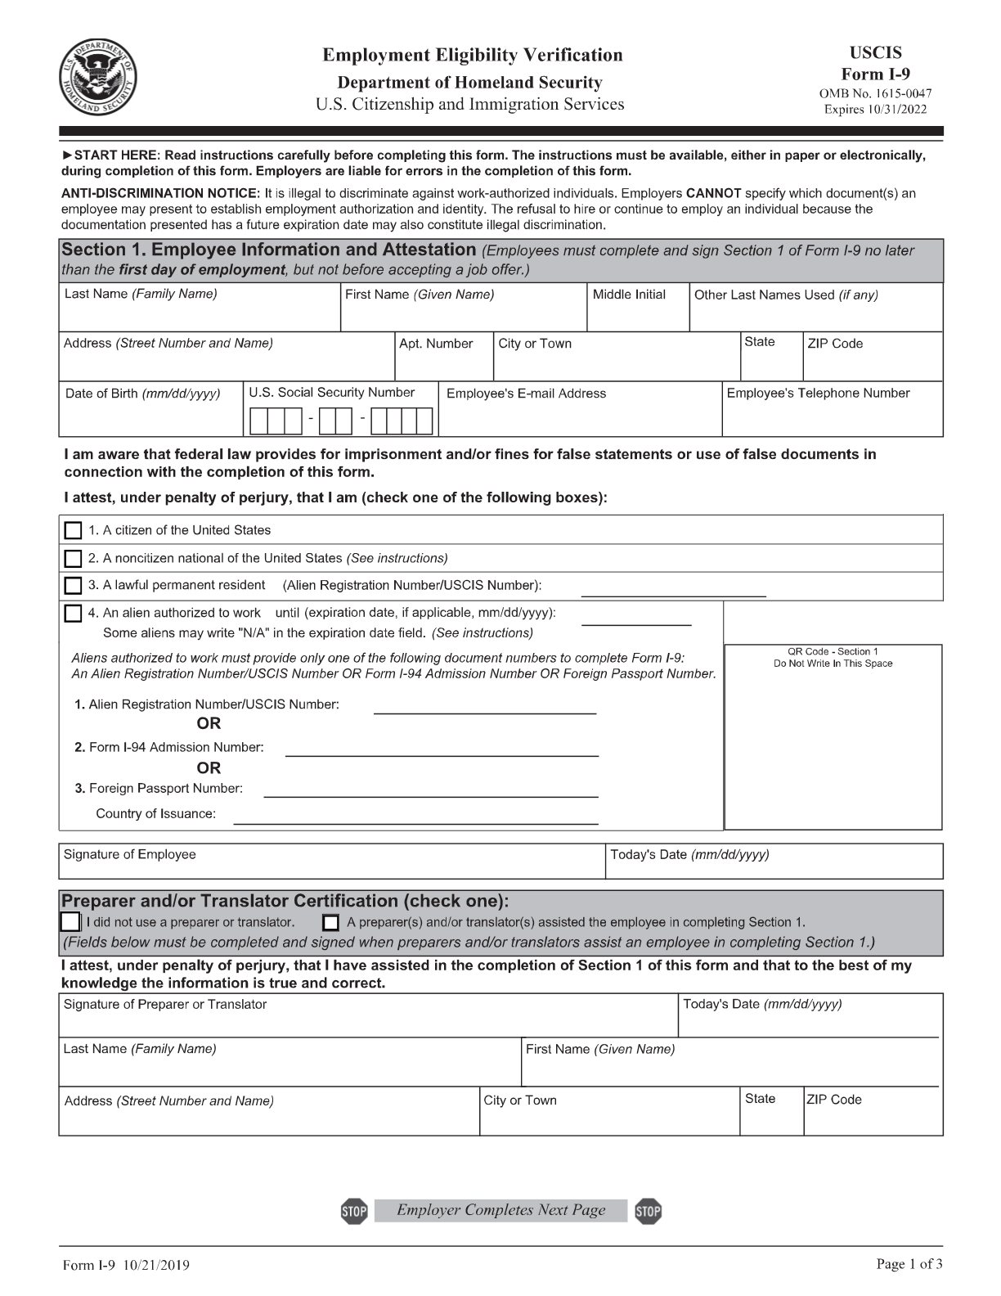
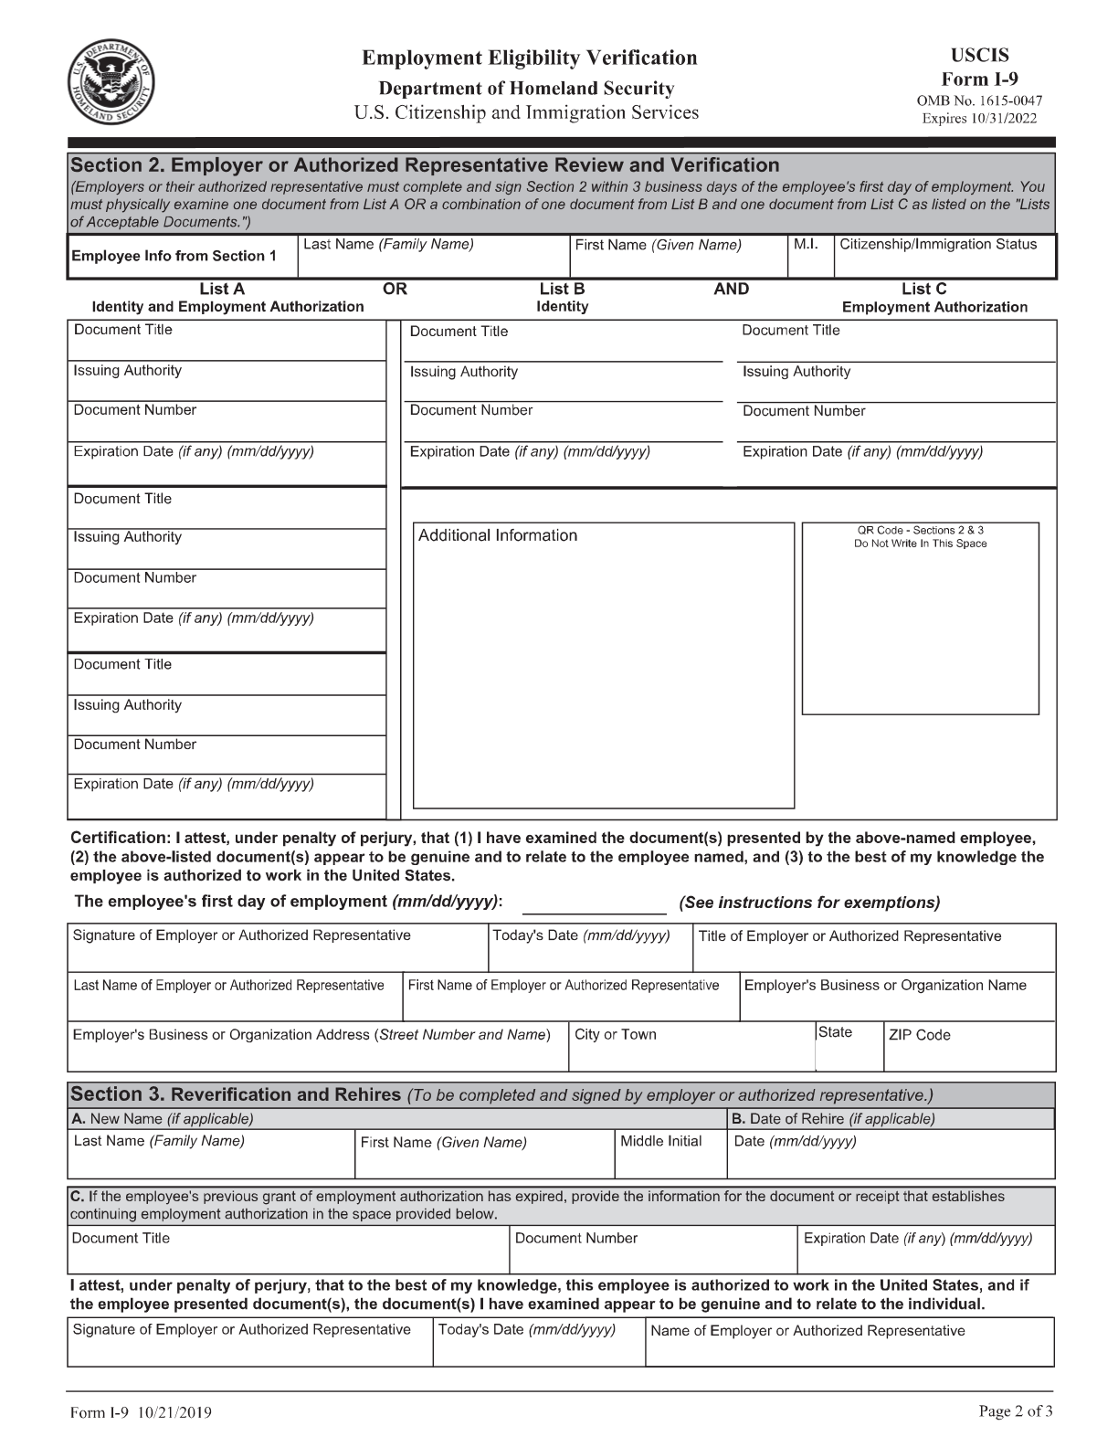

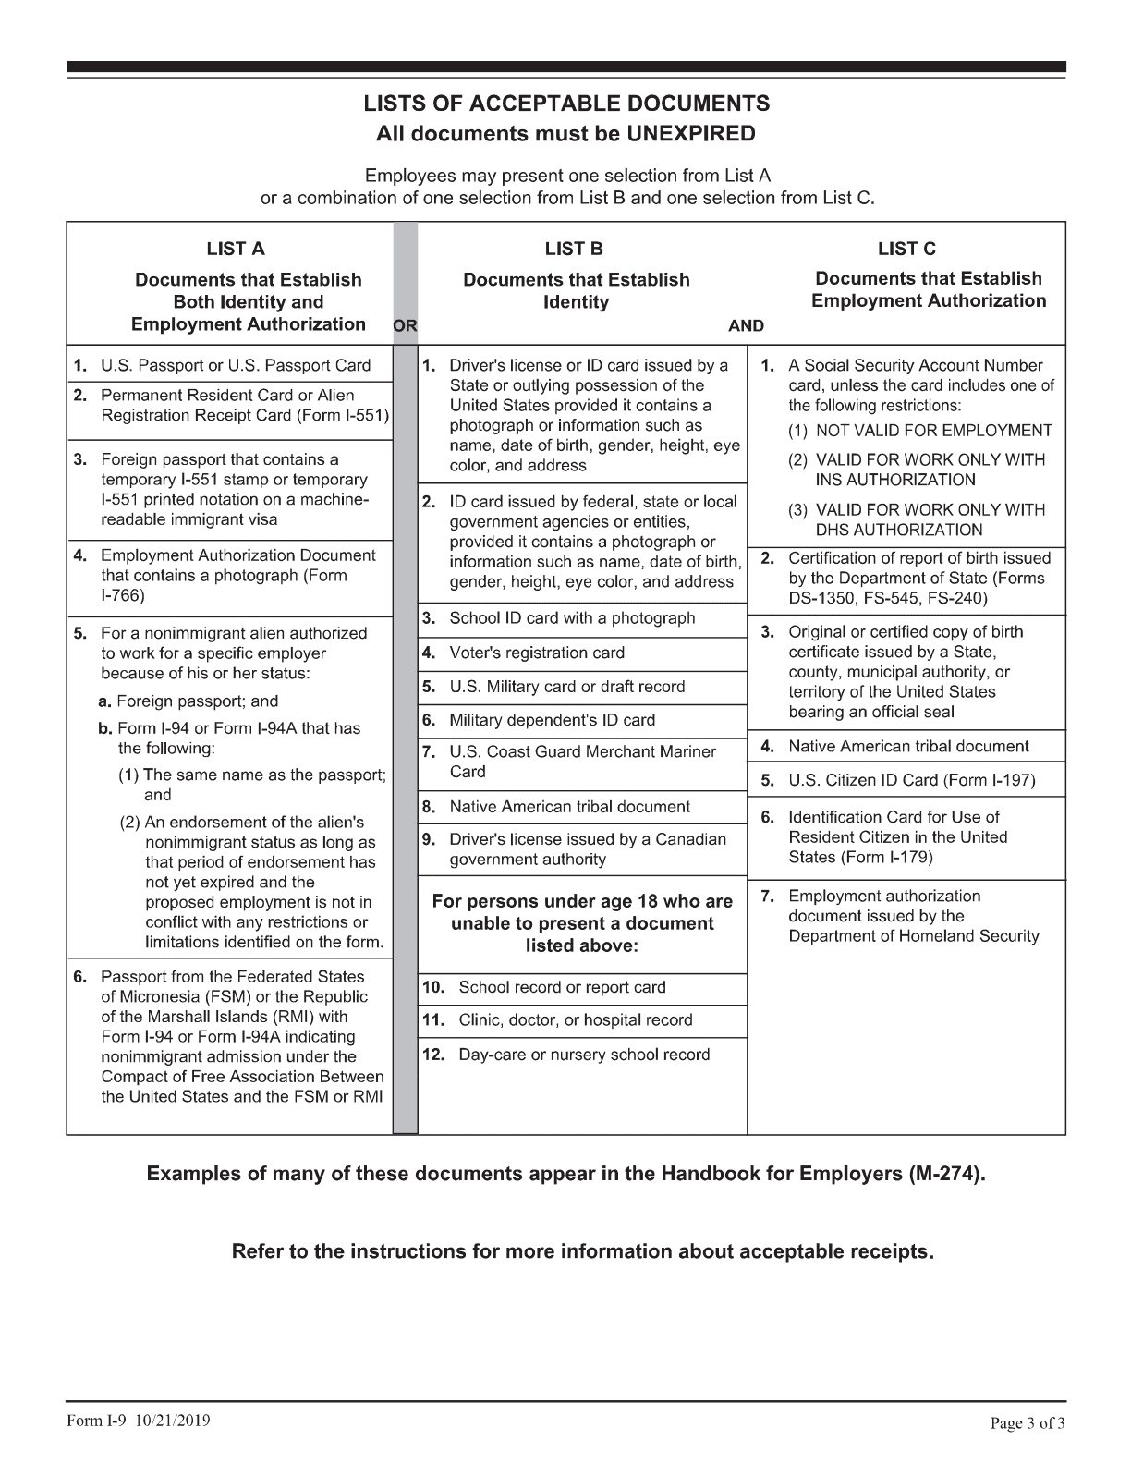

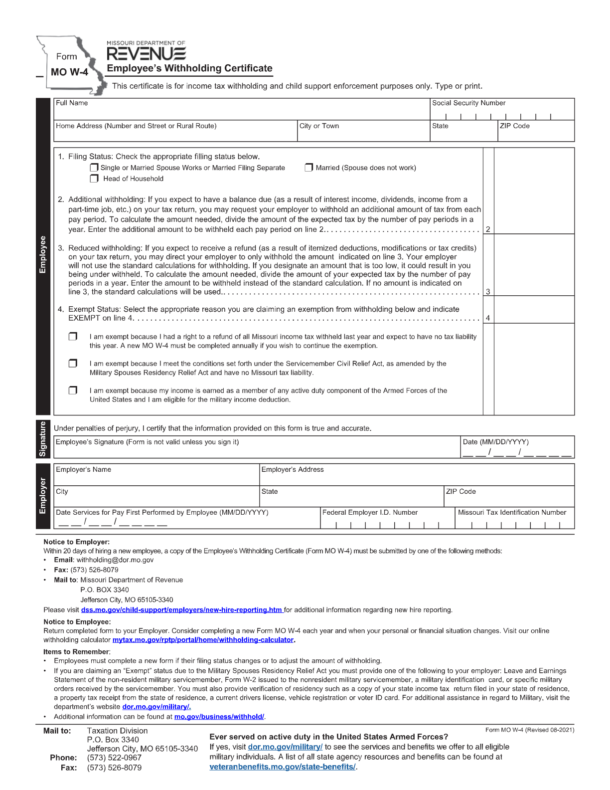

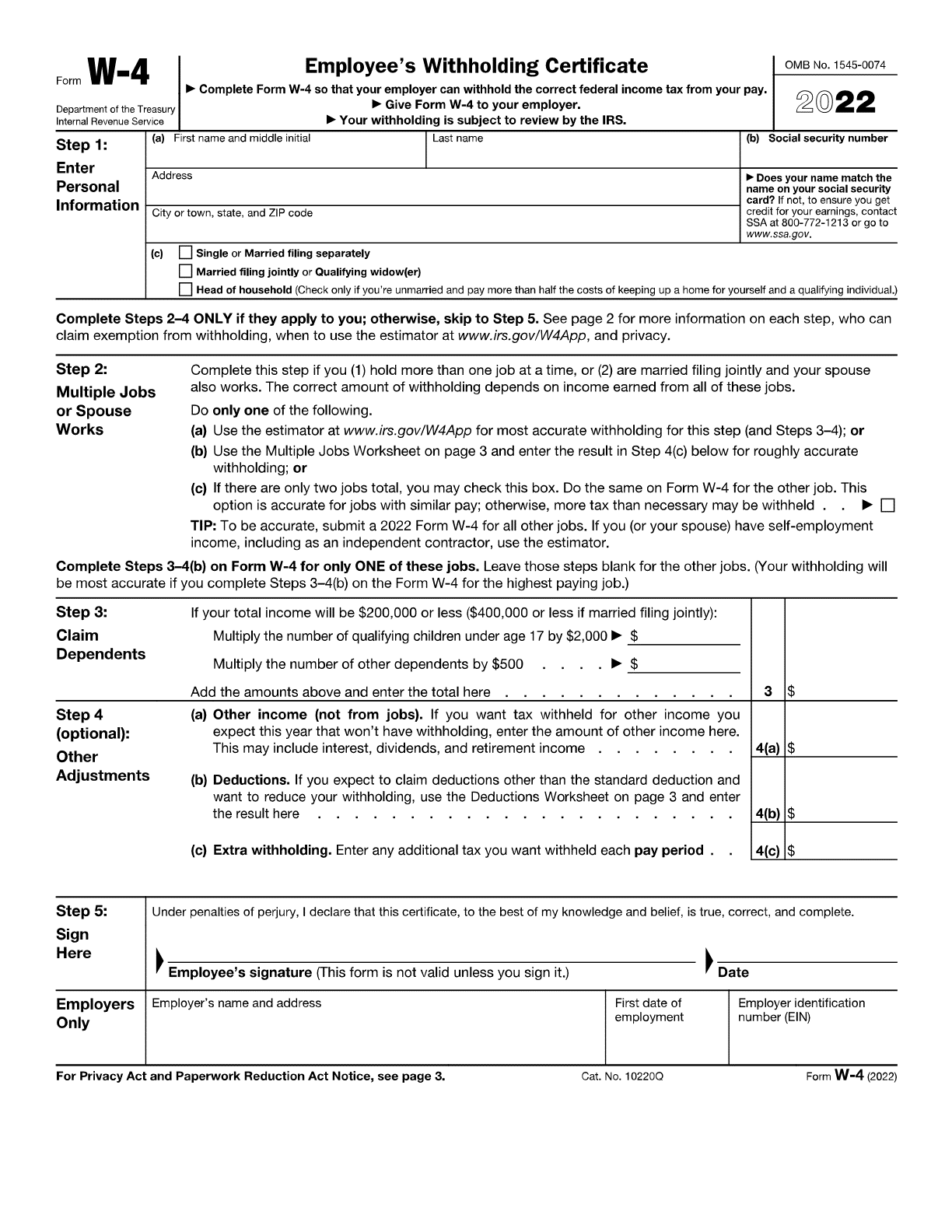

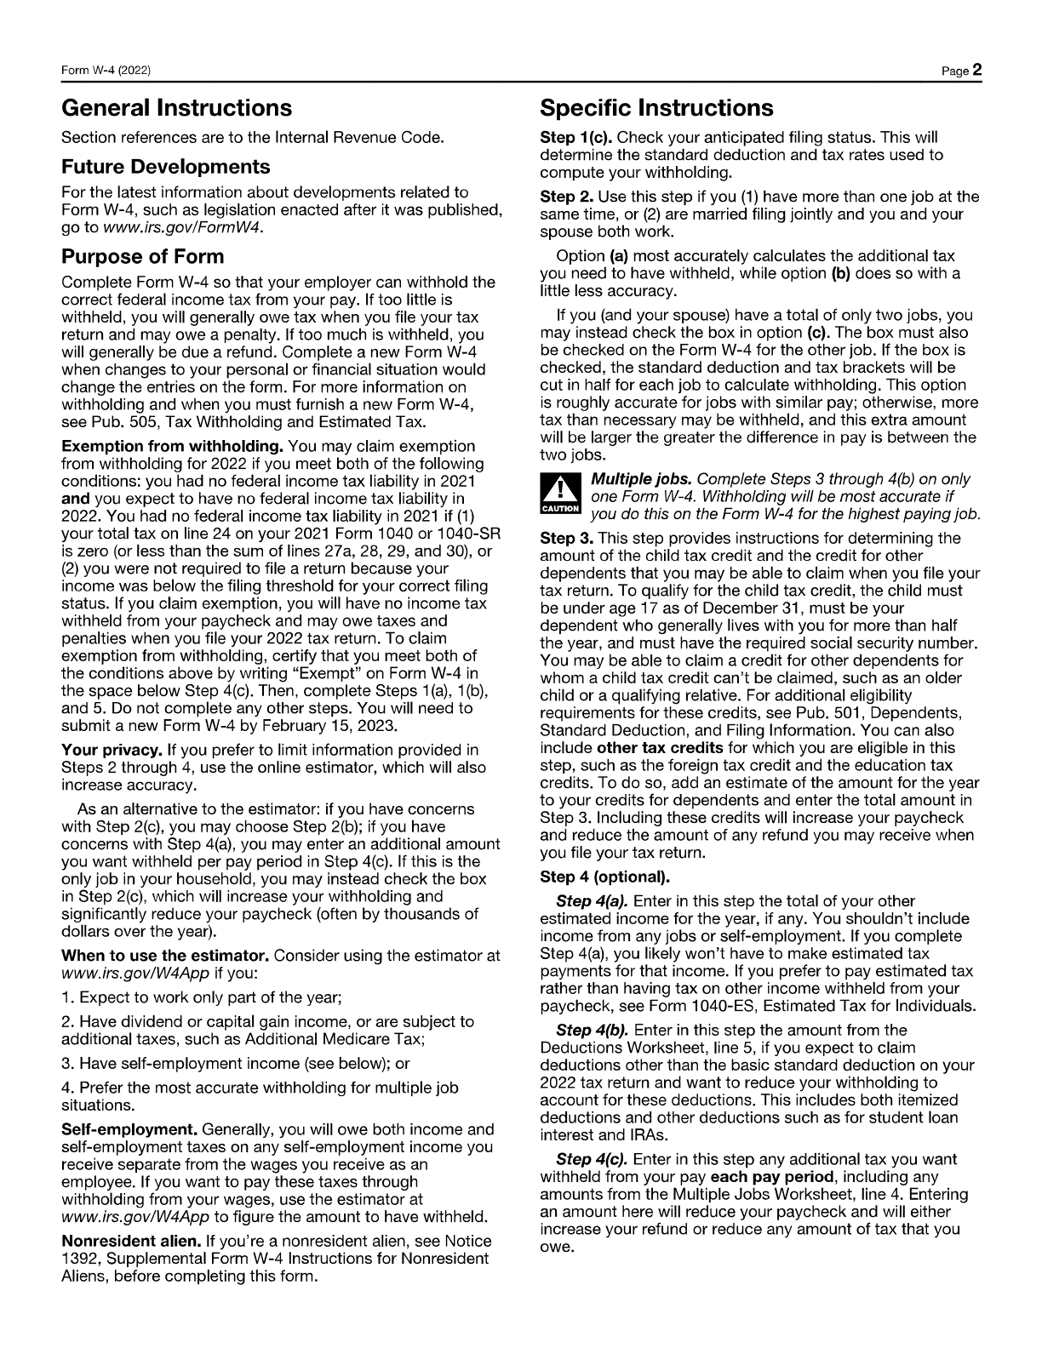

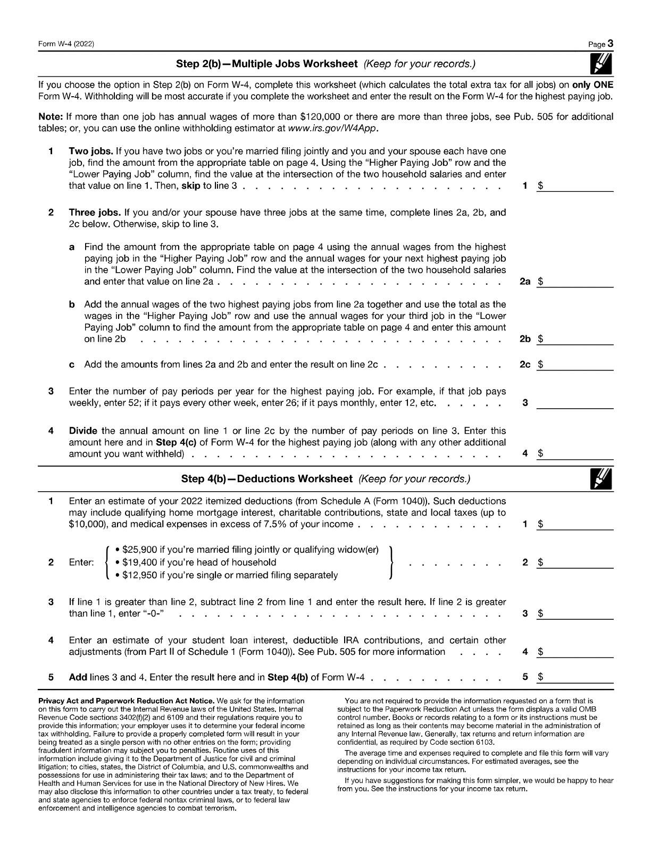

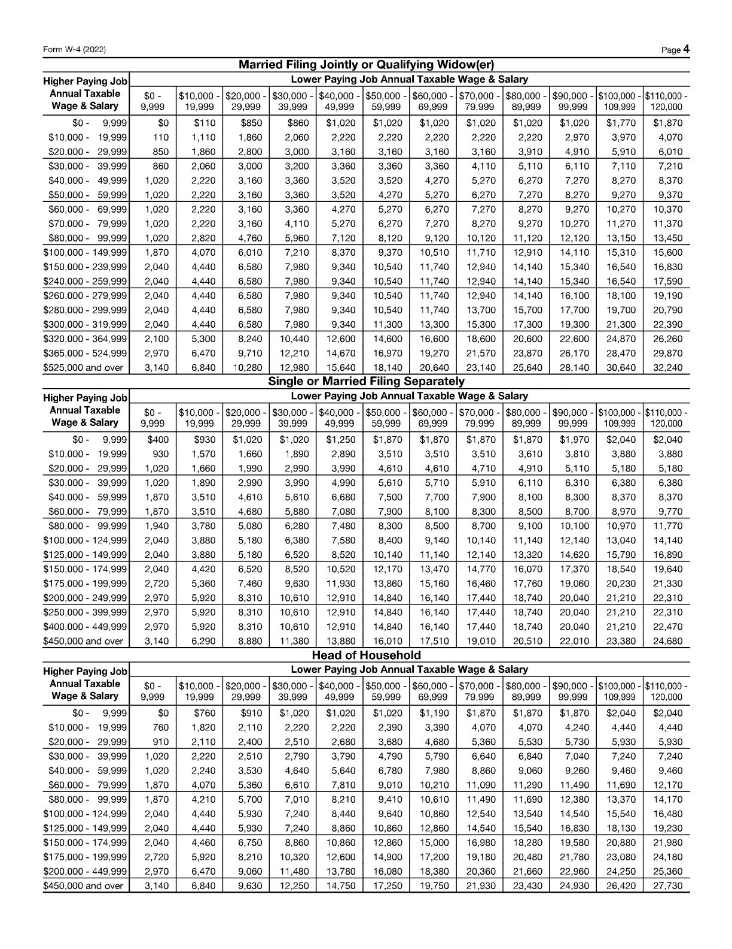

P.C.S. Home Health INC.
Pay Periods 2023

Pay Periods Pay Dates
January 1st Jan 15th February 15th
January 16th Jan 31st February 28th
February 1st Feb 15th March 15th
February 15th Feb 28th March 30th
March 1st March 15th April 15th
March 16th March 30th April 30th
April 1st April 15th May 15th
April 16th April 30th May 31st
May 1st May 15th June 15th
May 16th May 31st June 30th
June 1st June 15th July 15th
June 16th June 30th July 31st
July 1st July 15th August 15th
July 16th July 31st August 31st
August 1st August 15th September 15th
August 16th August 31st September 30th
September 1st September 15th October 15th
September 15th September 30th October 31st
October 1st October 15th November 15th
October 16th October 31st November 30th
November 1st November 15th December 15th
November 16th November 30th December 31st
December 1st December 15th January 15th
December 16th December 31st January 31st
- If the 15th or the 30th falls on a Saturday or Sunday, you will be paid the Friday before.
- If you have any questions about the scheduling, feel free to reach out to me at any time.
P.C.S. Home Health INC.
Brandon Killiebrew (314) 388-1530

P.C.S. HOME HEALTH
EMPLOYEE INTAKE
PACKET

